This is to certify that
Mr./Ms _ _ _ _ _ _ _ _ _ _ _ _

Has successfully Designed &
Developed
_ _ _ _ _ _ _ _ _ _ _ _ _ _ _ _ _

Submitted by:
_ _ _ _ _ _ _ _ _ _ _ _ _ _ _ _ _

Date of Issue: _ _ _ _ _ _ _ _ _

Authorized Signature : _ _ _ _ _ _ _ _

Problem Defination:
1) The products even after being very popular in the market and the sales increasing there are some probable customers who want to view the product, learn about the features and product specifications in terms of storage technique, overall looks etc.

2) Some probable customers would also like to compare the various products within the same category. For e.g. there are 2 different types of CD ROM Drives one with max speed 24X and the other with 52X.

2) The product range is not known to quite a few customers they just order on the basis of the feedback or recommendations given by their friends or colleagues and after delivery of the product it does not match either the requirements or expectations leading to wastage of time, resources and delivery costs.

3) Existing customers needing some help and support on the product after installation would have to call the oceangate office (difficult with phone lines continuously Busy) who would take their call and send the Service centre people to the place where the product is installed.
Business/Project Objective:
(Can address organization/business overview, Product, concerns, and expectations from the system)
Input provided by the clients:
Input to the system
Output from the system
Process involved in the system
Expected delivery dates
List of deliverables
Hardware Requirements:
• A minimum computer system that will help you access all the tools in the courses is a Pentium 166 or better
• 64 Megabytes of RAM or better
Software Requirements:
• Notepad/HTML editor/CoffeeCup
• Angular / Angular JS / React / BootStrap
• Dreamweaver / Figma
• MS IE / Chrome / FireFox / Netscape /MS Edge

Scope of the work (in brief):
Architecture and Design of the Project:
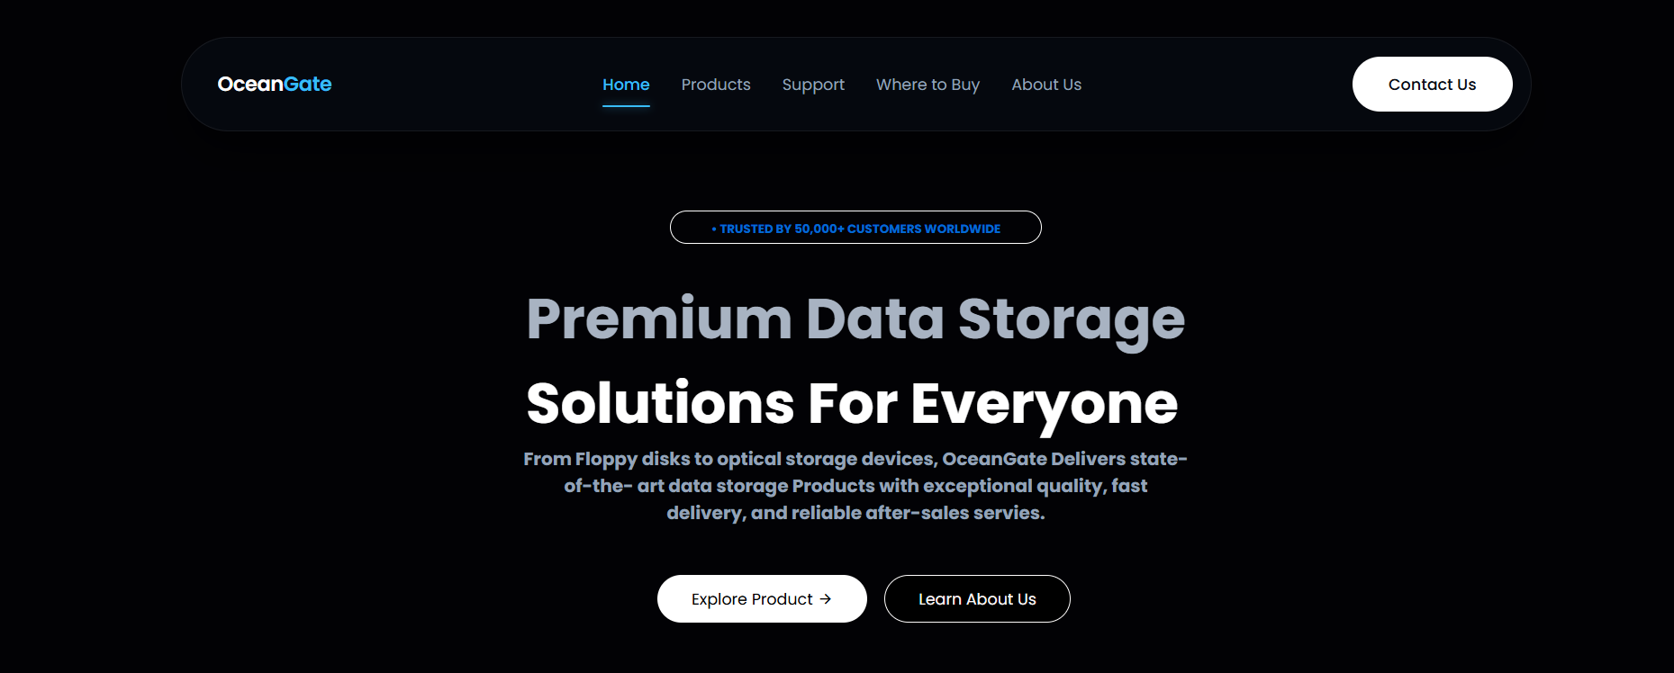
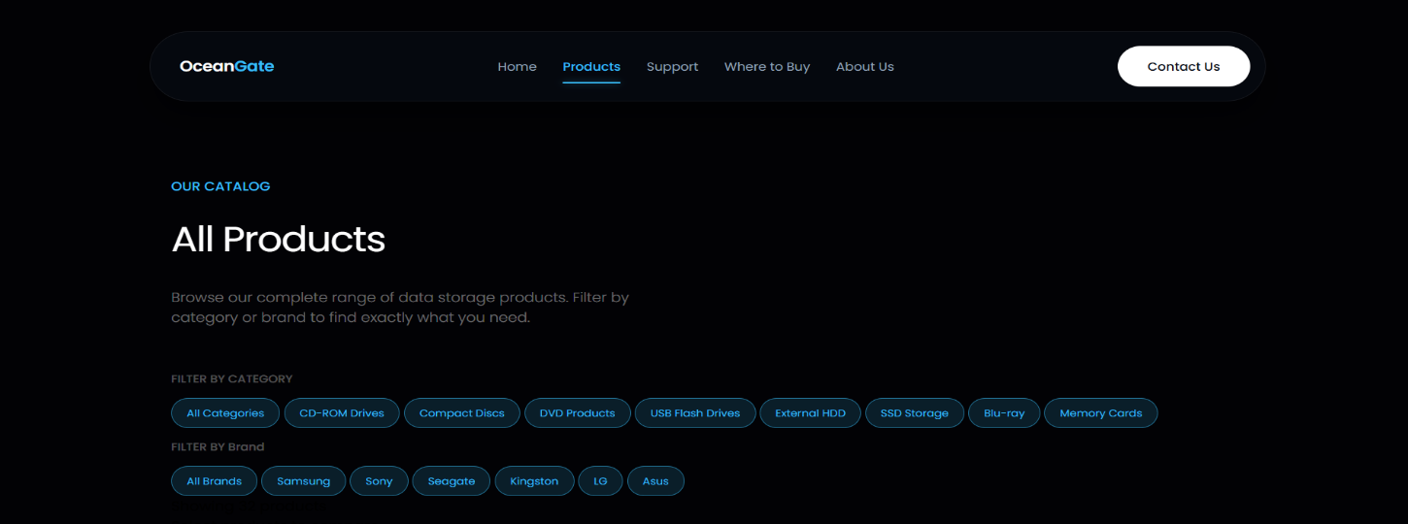
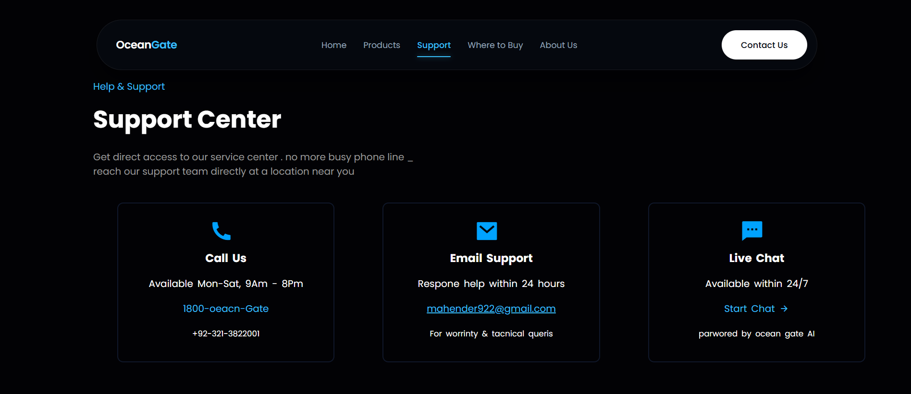

Data Flow Daigram (DFD):

``